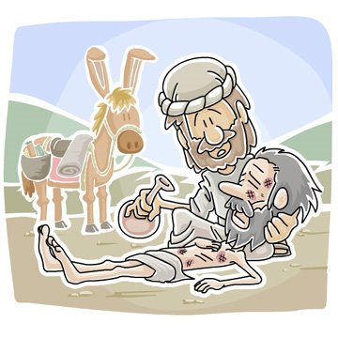

First Baptist Church - Day Camp
9:00 am to 2:30 pm
Walker Farm
17610 State Rt. 23, DeKalb
(one mile south of town on Fourth Street)
July 23-27, 2018

Things to know for a safe and enjoyable day camp experience:

Food: Bring a sack lunch every day but Wednesday. (Wednesday we will have a cook-out.) Water and lemonade and a morning snack will be provided every day. If there are special dietary concerns, please let us know or send appropriate food with your child. Campers should bring a water bottle every day.

Fun in the sun: Be sure your child has sunscreen. We will remind the children to put on sunscreen before swimming. Your child should bring a modest swim suit (no bikinis) and a towel. Flip flops may be worn to and from the pool if desired.

Shoes: Your child will need to wear closed-toe shoes (such as tennis shoes) to Day Camp each day.

Clothes: Dress should be appropriate for the weather, which could be hot and sunny or cold and rainy.

Unplug: Please leave all electronics at home, including phones. We cannot be responsible for things that could be easily lost or broken in a camp environment. In case of emergency, adult staff members will have access to phones.

Emergency Contact Information:
Elaine Cozort, Camp Director, 815-501-2401 (cell)
Jon Self, Camp Pastor, 815-501-3061 (cell)

